

**SC2207 Lab 3**

**Tutorial Group A34, Group 3**

**Group members:**

Hendy (U2122559J)

Cai Kaihang (U2121031J)

Lim Jin Feng, Alexus (U2121689H)

Yeoh Ming Wei (U2123351B)

Sim Wei Feng (U2122824G)

## 

## 

## **INDIVIDUAL CONTRIBUTION FORM**

| Full Name | Individual Contribution to Lab 3 Submission | Percentage of  Contribution | Signature |
| --- | --- | --- | --- |
| Hendy | Discussed and Designed Revised ER Diagram  Discussed Generation of Normalised Database Schema | 20% |  |
| Lim Jin Feng, Alexus | Discussed and Designed Revised ER Diagram  Discussed Generation of Normalised Database Schema | 20% |  |
| Cai Kaihang | Discussed and Designed Revised ER Diagram  Discussed Generation of Normalised Database Schema | 20% |  |
| Yeoh Ming Wei | Discussed and Designed Revised ER Diagram  Discussed Generation of Normalised Database Schema | 20% |  |
| Sim Wei Feng | Discussed and Designed Revised ER Diagram  Discussed Generation of Normalised Database Schema | 20% |  |

Revised ER diagram

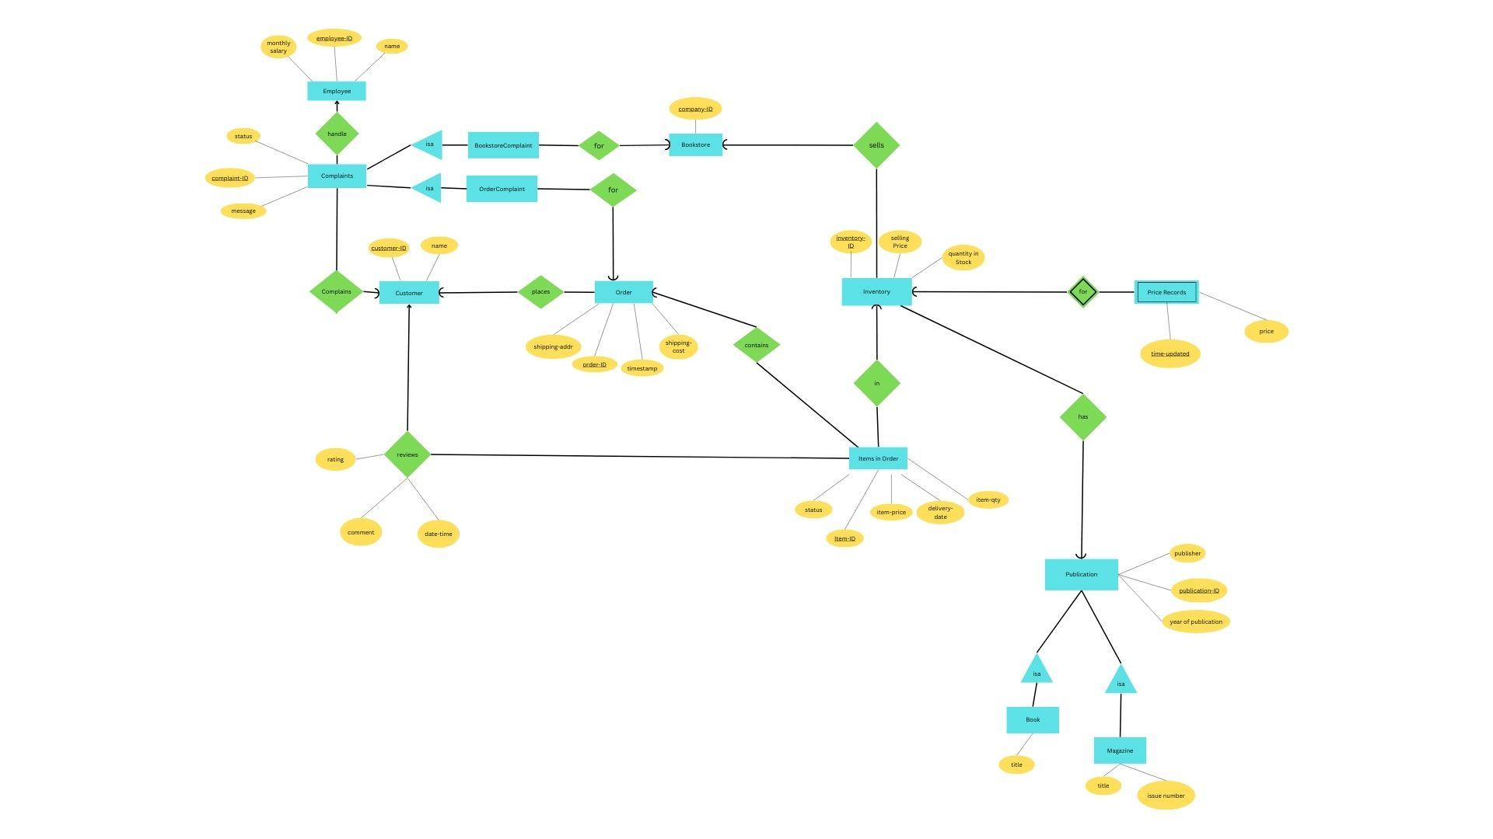

**Normalized relational schema (BCNF)**

Magazine (publication-ID, issue number, title)

Key: publication-ID

Primary Key: publication-ID

FDs: publication-ID → issue number, publication-ID, title

**The relation is in BCNF**

Publication (publication-ID, publisher, year of publication)

Key: publication-ID

Primary Key: publication-ID

FDs: publication-ID → publisher, year of publication

**The relation is in BCNF**

Book (publication-ID, title)

Key: publication-ID

Primary Key: publication-ID

FDs: publication-ID → title

**The relation is in BCNF**

Customer (customerID, name)

Key: customerID

Primary Key: customerID

FDs: customerID → name

**The relation is in BCNF**

BookstoreComplaint (complaint-ID, company-ID)

Key: complaint-ID

Primary Key: complaint-ID

FDs: complaint-ID → company-ID

**The relation is in BCNF**

OrderComplaint (complaint-ID,order-ID)

Key: complaint-ID

Primary Key: complaint-ID

FDs: complaint-ID → order-ID

**The relation is in BCNF**

Complaints (complaint-ID, employee-ID, customer-ID, message, status)

Key: complaint-ID

Primary Key: complaint-ID

FDs: complaint-ID → employee-ID, customer-ID, message, status

**The relation is in BCNF**

Employee (employee-ID, name, monthly-salary)

Key: employee-ID

Primary Key: employee-ID

FDs: employee-ID → name, monthly-salary

**The relation is in BCNF**

Order (order-ID, shipping-addr, shipping-cost, timestamp,customer-ID).

Key: order-ID

Primary Key: order-ID

FDs: order-ID → shipping-addr, shipping-cost, timestamp,customer-ID (in BCNF)

shipping-addr → shipping-cost

*(Assumption: shipping source is always the same (from Amazon warehouse), so the shipping address determines shipping cost)*

The relation order-ID → shipping-addr, shipping-cost, timestamp,customer-ID is in BCNF while shipping-addr → shipping-cost is **not in BCNF.**

**Perform normalization steps**:

R1(shipping-addr, shipping-cost)

R2(order-ID, shipping-addr, timestamp, customer-ID)

Now both **relations are in BCNF.**

Inventory (inventory-ID, selling-price, qty-in-stock, publication-ID, company-ID)

Key: inventory-ID, {company-ID, publication-ID}

Primary Key: inventory-ID

FDs: inventory-ID → selling-price, qty-in-stock, publication-ID, company-ID;

company-ID, publication-ID → inventory-ID

**The relation is in BCNF**

Price_Records (time-updated, inventory-ID, price )

Key : time-updated, inventory-ID

Primary Key: time-updated, inventory-ID

FDs: time-updated,inventory-ID → price

**The relation is in BCNF**

Bookstore (company-ID)

Key: company-ID

Primary Key: company-ID

**The relation is in BCNF**

Items_In_Order (item-ID, order-ID, inventory-ID, customer-ID, item-price, item-qty, status, delivery-date, rating, comment, date-time)

Key: item-ID

Primary Key: item-ID

FDs: item-ID -> order-ID, inventory-ID, customer-ID, item-price, item-qty, status, delivery-date, rating, comment, date-time

*(Assumption: item-ID is unique, there is no repetition of item-ID across different orders. Similar to inventory-ID from Inventory table)*

order-ID -> customer-ID

Decompose Items_In_Order into Cust_Order(order-ID, customer-ID) and Items_In_Order(item-ID, order-ID, inventory-ID, item-price, item-qty, status, delivery-date, rating, comment, date-time)

Since Cust_Order(order-ID, customer-ID) is a subset of Order(order-ID, shipping-addr, shipping-cost, timestamp,customer-ID), we can exclude Cust_Order and just leave **Items_In_Order(item-ID, order-ID, inventory-ID, item-price, item-qty, status, delivery-date, rating, comment, date-time).**

**The relation is in BCNF**